**Money Tracker**

An Money tracker is a platform where we will list all our income and expenditures from various sources like salary , freelance, food, travel, medical, education etc to make an analysis about our money. So we can have any idea where we are spending our amount.

**Implementation-**

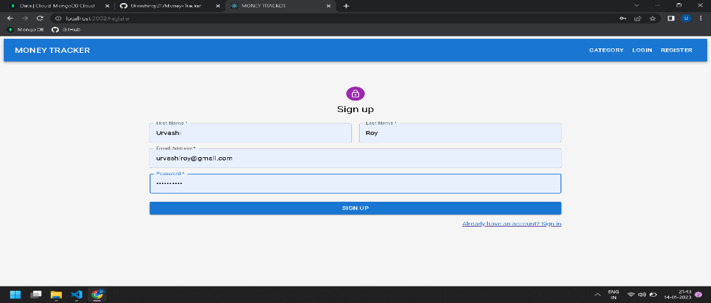

Sign up page:

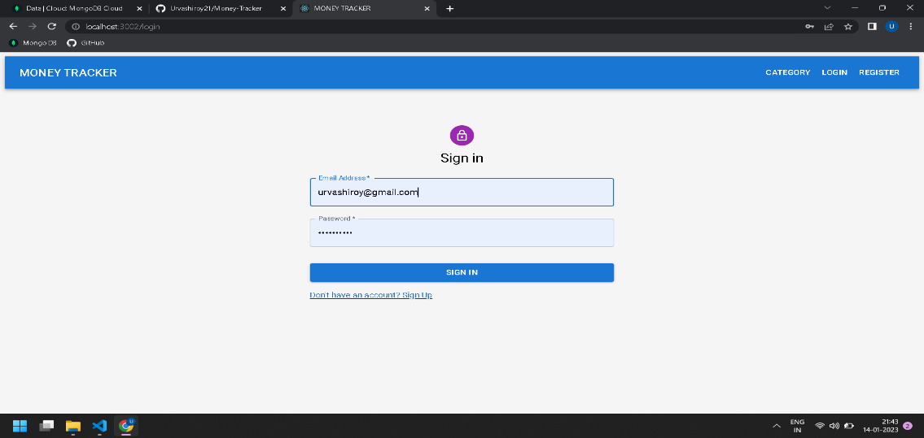

Sign in page:

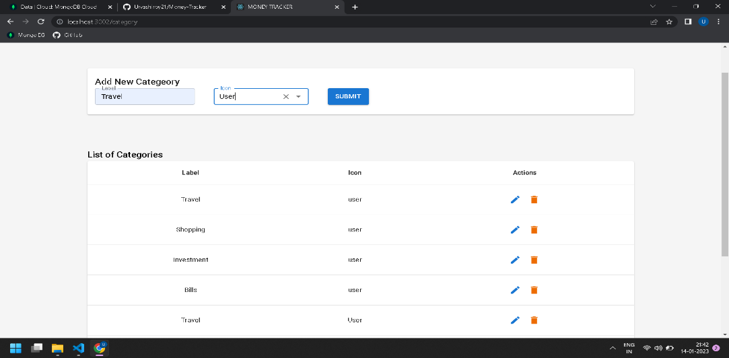

Categories page:

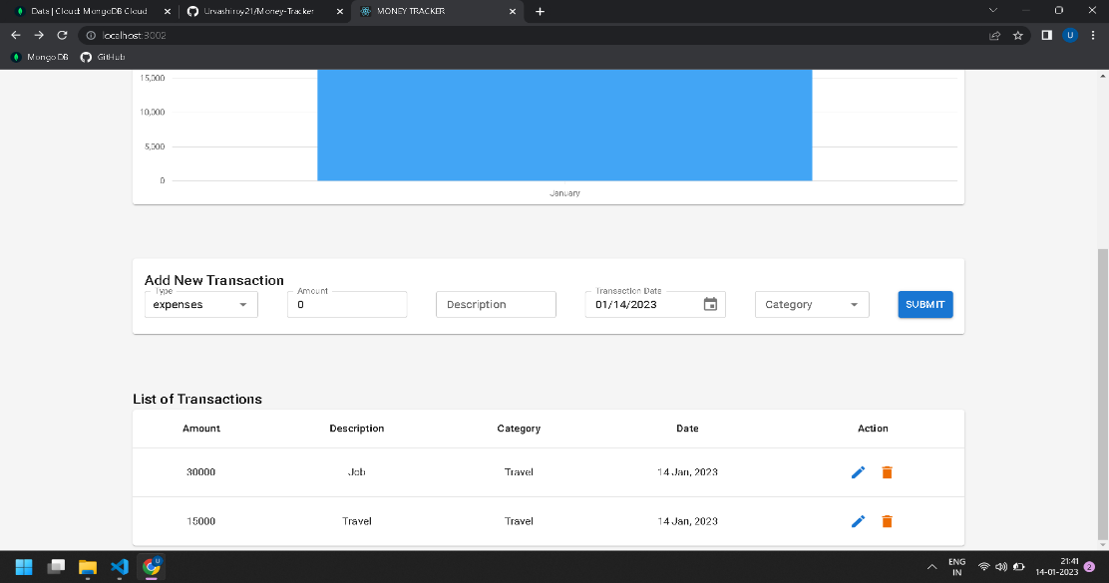

Money Tracker 1 page:

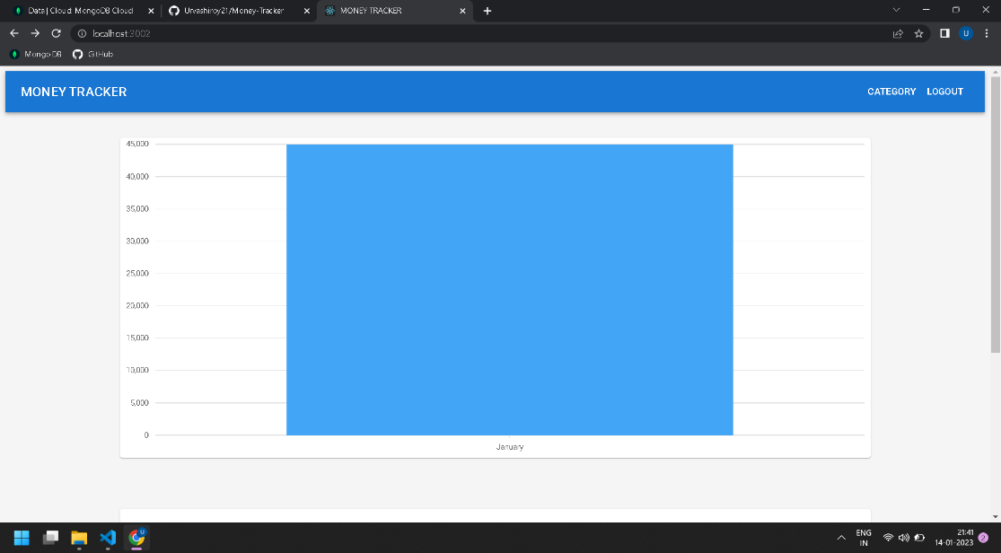

Money Tracker 2 page:

v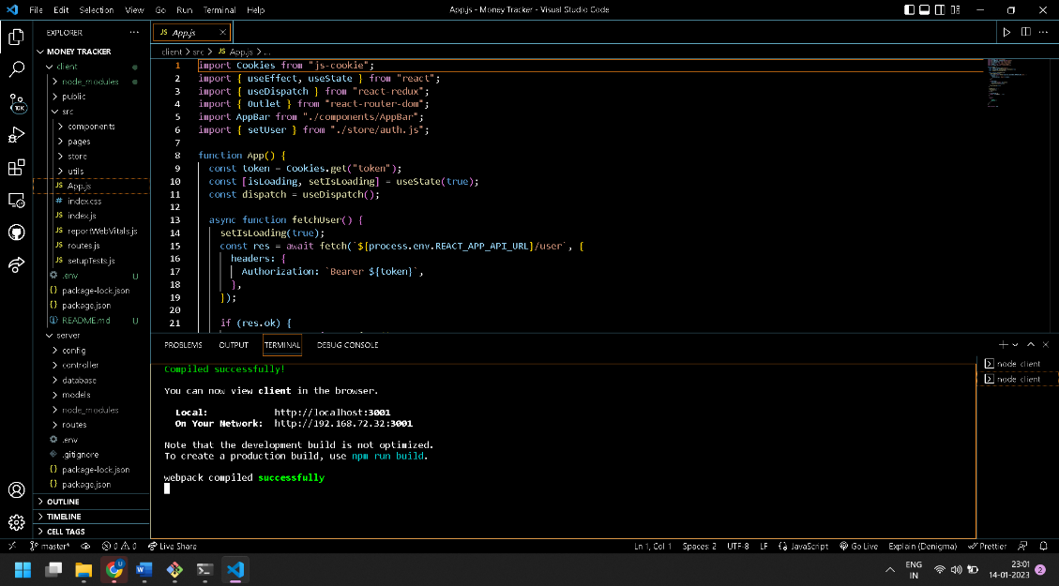

For run the code :

* cd client
* npm install
* npm run start